https://git-scm.com/download/win

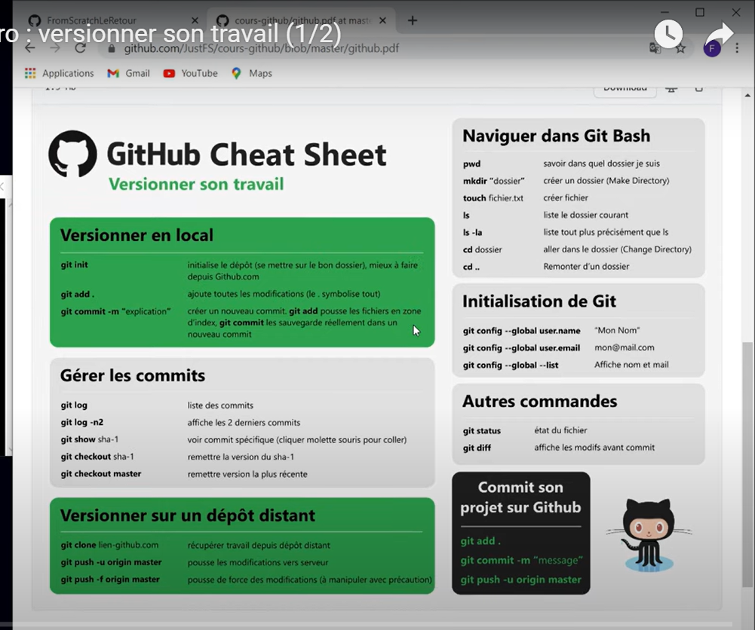

* Git status
* Repositiry votre non .github.io